Full Stack Development with MERN
Project Documentation
Customer Registry
A MERN-Stack Complaint & Customer Management System

1. Introduction

Project Title
Customer Registry – a MERN-stack (MongoDB, Express, React, Node.js) complaint and customer management platform.

Team Members
Name | Role
Karthik Vasabhaktula | Team Lead
Eswar Yaswanth Kumar Koda | Member
Sharoof Mohammad | Member
Sai Sarvani Balivada | Member
Appala Lakshmi Priya | Member

2. Project Overview

Purpose
Customers who raise complaints with a business often have no transparent way to track who is handling their issue or what its current status is. Customer Registry solves this by giving every complaint a single, traceable record shared by three roles – the Customer who raises it, the Support Agent who resolves it, and the Admin who oversees the whole operation – tied together with in-app messaging and notifications so nobody has to chase updates over phone or email.

Features
- Role-based registration and login (Customer, Agent, Admin) secured with JWT.
- Customers can submit a complaint with contact details and a description, and track its status (pending / in-progress / resolved).
- Admins assign complaints to specific agents; agents see only the complaints assigned to them.
- Built-in one-to-one messaging between a customer and the agent working on their complaint.
- In-app notifications for both customers and agents on status changes and new messages.
- Admin console to manage complaint categories, agents and users, and to view every complaint in the system.

3. Architecture

Frontend (React)
The client is a React 18 single-page application (Create React App) using react-router-dom v6 for routing. Pages are organised by audience: components/ for customer-facing pages (Home, Registration, Login, Complaint, MyComplaints, Chat), agent_components/ for the agent dashboard and chat, and admin_components/ for the admin console (Dashboard, Complaints, Customers, Agents, Users, AddCategory, AddProduct). Role-specific route guards – ProtectedRoute, AgentProtectedRoute and AdminProtectedRoute – check for a stored token before rendering a page and redirect to /login if it is missing. Styling is a mix of styled-components and react-bootstrap, and axios handles all API calls.

Backend (Node.js & Express)
The server is a Node.js/Express REST API organised into routes, controllers, models and a single JWT auth middleware (src/middleware/authMiddleware.js). Each resource – auth, users, complaints, agents, messages, notifications, categories – has its own route file mounted under /api in src/app.js, with the corresponding controller containing the business logic and Mongoose models defining the schema.

Database (MongoDB)
Data is stored in MongoDB (Atlas in production) through seven Mongoose collections:
Collection | Purpose | Key Fields
Customer | Every registered person – customer, agent or admin – distinguished by a type field | firstname, lastname, username, type, email (unique), password (hashed)
Complaint | A single complaint raised by a customer | customer (ref), name, phone, email, complaintDetails, status, agent, createdAt
Agent | Assignment record linking a complaint to the agent handling it | complaintId, customerId (ref Customer), agentId, createdAt
Category | Complaint categories managed by the admin | category (unique), description
Communication | Chat messages between a customer and an agent | senderId (ref), receiverId (ref), content, createdAt
Notification | In-app notifications for customers | userId, senderId, content, isRead, createdAt
AgentNotification | In-app notifications for agents | userId, senderId, content, isRead, createdAt
Note: the Agent collection's agentId field is defined with ref: 'Agent' rather than ref: 'Customer', even though agents are Customer documents with type "agent" – see Known Issues.

4. Setup Instructions

Prerequisites
- Node.js v16 or later and npm
- A MongoDB Atlas cluster (or a local MongoDB instance) and its connection string
- Git

Installation
1. Clone the repository:
git clone https://github.com/Karthik-Vasabhaktula/customer_registry.git
cd customer_registry
2. Install server dependencies and configure environment variables:
cd server
npm install
Create a .env file inside server/ with:
PORT=5100
MONGO_URI=<your MongoDB Atlas connection string>
JWT_SECRET=<a long random string>
3. Install client dependencies:
cd ../client
npm install

5. Folder Structure

Client (client/src)
components/ Customer-facing pages (Home, Registration, Login,
Complaint, MyComplaints, Chat, Header, Footer, ...)
agent_components/ Agent dashboard, agent chat, AgentProtectedRoute
admin_components/ Admin dashboard, Complaints, Customers, Agents,
Users, AddCategory, AddProduct, Sidebar
context/ Shared React context
App.js Route definitions

Server (server/src)
config/db.js MongoDB connection setup
controllers/ Business logic for each resource
middleware/ JWT authMiddleware (with optional role check)
models/ Mongoose schemas (7 collections)
routes/ Express routers, one per resource
app.js App entry point – mounts all /api routes

6. Running the Application
Backend – from the server directory (the project defines a dev script, not start):
npm run dev
# runs: nodemon src/app.js → http://localhost:5100
Frontend – from the client directory:
npm start
# runs: react-scripts start → http://localhost:3000

7. API Documentation
All endpoints are mounted under /api. None currently enforce the JWT middleware at the route level (see Known Issues) – the token is issued at login and used by the client, but route files call controllers directly.

Auth – /api/auth
Method | Endpoint | Body / Params | Response
POST | /register | firstname, lastname, username, type, email, password | 201 { msg: "User registered successfully" }
POST | /login | email, password | 200 { token, user: { _id, firstname, email, type } }

Users – /api/users
Method | Endpoint | Params | Response
GET | / | – | 200 [ ...all Customer documents ]
GET | /:id | id (path) | 200 { ...Customer document }

Complaints – /api/complaints
Method | Endpoint | Body / Params | Response
POST | / | customer, name, phone, email, complaintDetails, agent | 201 { ...new Complaint }
PUT | /:id/update-status | id (path); status (body) | 200 { ...updated Complaint }
GET | / | – | 200 [ ...all complaints ]
GET | /agent/:id | id (path) – agent id | 200 [ ...complaints for that agent ]
GET | /customer/:id | id (path) – customer id | 200 [ ...complaints for that customer ]

Agents – /api/agents
Method | Endpoint | Body / Params | Response
POST | / | complaintId, customerId, agentId | 201 { ...new assignment }
GET | /:id | id (path) – agent id | 200 [ ...assignments for that agent ]

Messages – /api/messages
Method | Endpoint | Body / Params | Response
POST | / | senderId, receiverId, content | 201 { ...new message }
GET | / | – | 200 [ ...all messages with sender/receiver info ]
GET | /user/:userId | userId (path) | 200 [ ...messages involving that user ]
GET | /:senderId/:receiverId | senderId, receiverId (path) | 200 [ ...conversation between the two ]

Notifications – /api/notifications
Method | Endpoint | Body / Params | Response
GET | /:userId | userId (path) | 200 [ ...customer notifications ]
GET | /agent/:userId | userId (path) | 200 [ ...agent notifications ]
POST | / | userId, senderId, content | 201 { ...new notification }
POST | /agent | userId, senderId, content | 201 { ...new agent notification }
DELETE | /:userId | userId (path) | 200 { msg: "Notifications deleted" }

Categories – /api/categories
Method | Endpoint | Body / Params | Response
POST | / | category, description | 201 { ...new category }
GET | / | – | 200 [ ...all categories ]

8. Authentication
Passwords are hashed with bcrypt (10 salt rounds) before being stored in the Customer collection. On login, the server verifies the password and issues a JWT signed with { userId, type } and a 1-hour expiry, using a JWT_SECRET from the environment (falling back to a hardcoded default if it is not set – see Known Issues).
The reusable auth(role) middleware in src/middleware/authMiddleware.js reads a Bearer token from the Authorization header, verifies it, and — if a role is passed in — checks that the token's type matches before calling next(). On the client, the token is used to gate access to role-specific pages:
- Customer routes – ProtectedRoute checks for a jwtToken cookie (via js-cookie).
- Agent routes – AgentProtectedRoute checks for an agentToken key in localStorage.
- Admin routes – AdminProtectedRoute checks for an adminJwtToken key in localStorage.
Each guard only confirms a token is present before rendering; it does not itself re-validate the token's signature or role on the client (that trust boundary is enforced server-side by the auth middleware wherever it is applied).

9. User Interface
Home page – landing screen with a prompt to raise a complaint.
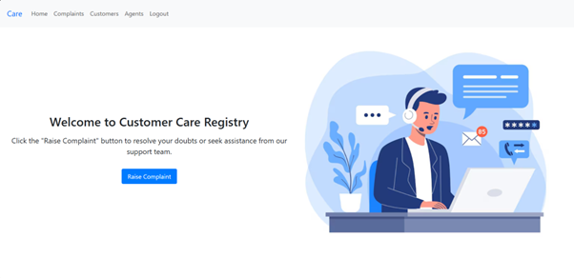
Figure 1: Home page
Sign Up – registration form capturing name, username, email, password and role type.
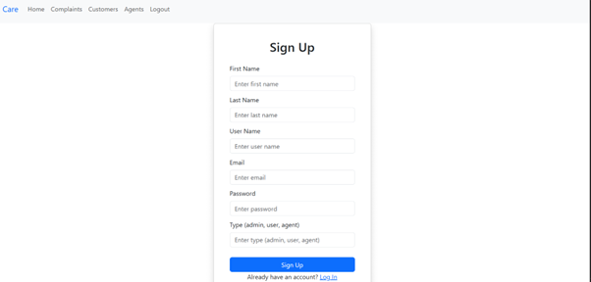
Figure 2: Sign Up page
Login – email/password authentication for all roles.
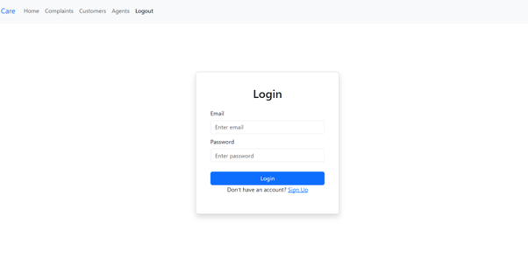
Figure 3: Login page
Raise Complaint – customer submits name, phone, email and complaint details.
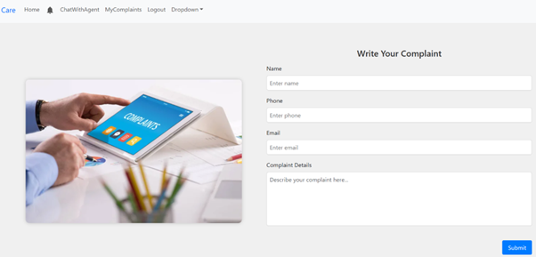
Figure 4: Write Your Complaint page
My Complaints – customer's own complaints with live status.
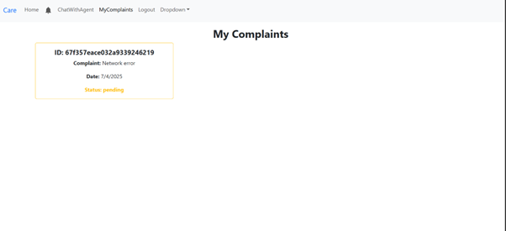
Figure 5: My Complaints page
Agent Chat – an agent's complaint summary alongside the in-app conversation with the customer.
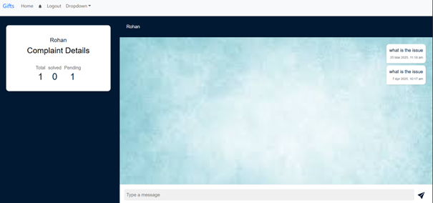
Figure 6: Agent – Complaint Details & Chat

10. Testing
API endpoints were tested manually with Postman across all six resource groups (auth, users, complaints, agents, messages, notifications, categories), covering both valid requests and common failure cases such as duplicate registration and invalid login credentials. Role-based workflows (customer → admin assignment → agent resolution → customer notification) were verified manually end-to-end through the UI for each of the three roles. There is currently no automated test suite: the client retains only the default Create React App placeholder test (App.test.js), and the server has no test script configured.

11. Screenshots or Demo

Demo video: Google Drive link
Source code: github.com/Karthik-Vasabhaktula/customer_registry
Additional annotated screenshots beyond Figures 1–6 above can be attached separately as they become available.

12. Known Issues
- JWT_SECRET falls back to a hardcoded default ("mysecretkey") if the environment variable is not set, which would be insecure in a real production deployment.
- Token storage is inconsistent across roles – customer tokens live in a cookie (jwtToken) while agent and admin tokens live in localStorage (agentToken, adminJwtToken) under different key names.
- The Agent model's agentId field references the Agent collection instead of Customer, even though agents are Customer documents with type "agent"; this reference does not currently resolve via populate().
- The Complaint document stores an agent field as a plain string alongside the separate Agent assignment collection, so assignment data is effectively duplicated across two places.
- Chat and notifications are fetched on demand rather than pushed in real time, so a customer or agent may need to refresh to see a new message or status change.
- There is no automated test coverage on either the client or the server.
- Complaints and messages have no file or image attachment support.

13. Future Enhancements
- Move from on-demand fetches to real-time updates for chat and notifications using Socket.IO.
- Add email or SMS notifications alongside the existing in-app notification feed.
- Support file and photo attachments on complaints and chat messages.
- Add SLA tracking and automatic escalation for complaints left open past a threshold.
- Build an analytics dashboard for admins (complaint volume by category, agent workload, resolution time).
- Introduce an automated test suite (Jest/React Testing Library on the client, Jest/Supertest on the server).
- Consistently enforce the existing auth(role) middleware on every protected route, and unify token storage across roles.
- Add pagination and search/filtering to complaint, message and notification lists as data volume grows.

